
SUBMITTED BY: Haider ud din
SUBMITTED TO: MR MUHAMMAD EJIZ
CLASS: BSSE 2023-C
SUBJECT: SOFTWARE CONSTRUCTION AND DEVELOPMENT
ROLL NO: 4257-C
SEMESTER: 5TH
SOFTWARE ENGINEERING

DATE: 29/11/2025

LAB TASK NO: 03K

Task 1:

Find the largest of three numbers
num1 = float(input("Enter first number: "))
num2 = float(input("Enter second number: "))
num3 = float(input("Enter third number: "))

if num1 >= num2 and num1 >= num3:
largest = num1
elif num2 >= num1 and num2 >= num3:
largest = num2
else:
largest = num3

print("The largest number is:", largest)
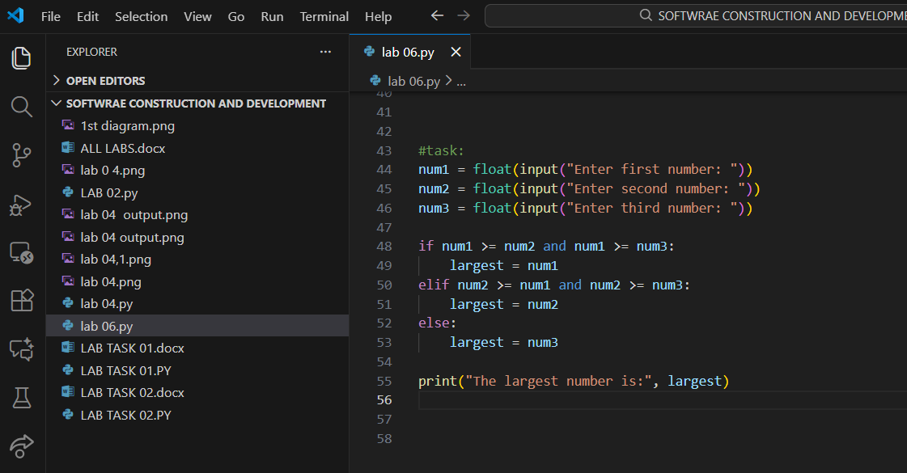

Output:
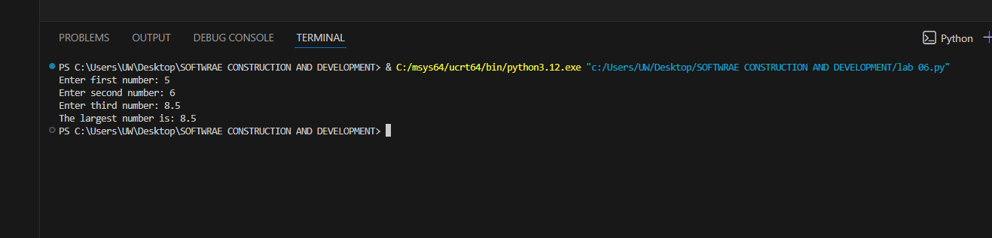

Task 2:

Calculate discount
total = float(input("Enter total amount: "))

if total >= 500:
discount = total * 0.20
print("Discount: 20%")
elif total >= 200:
discount = total * 0.10
print("Discount: 10%")
else:
discount = 0
print("No discount")

final_price = total - discount
print("Final price:", final_price)
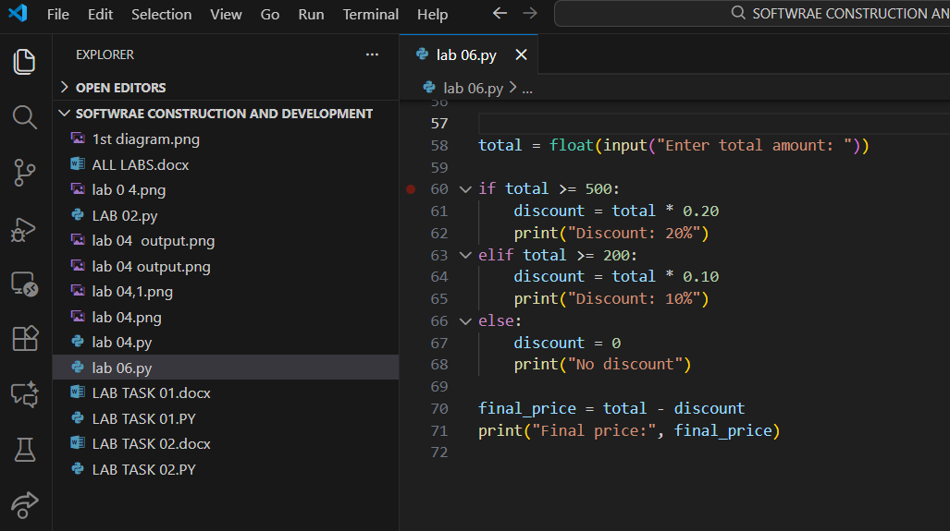
Output:

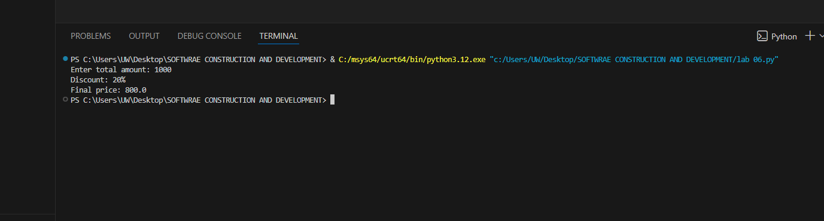

Task 3:

Login system
username = input("Enter username: ")
password = input("Enter password: ")

if username == "admin" and password == "pass123":
print("Login successful")
else:
print("Login failed")

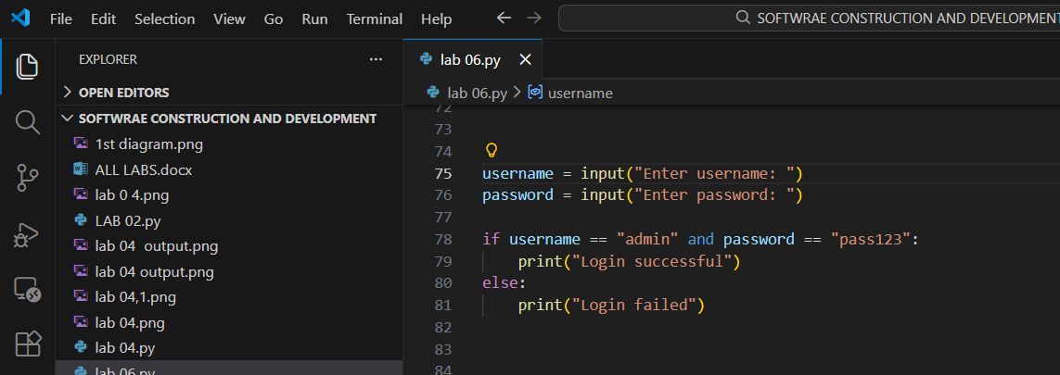

Output:
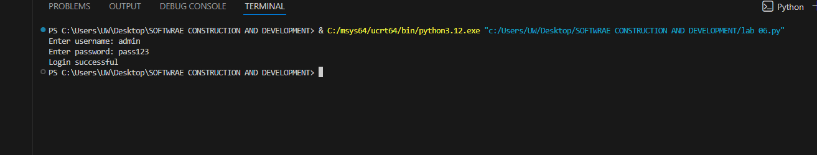

Task 4:

Password strength checker
password = input("Enter a password: ")

if len(password) < 6:
print("Weak")
elif len(password) <= 10:
print("Medium")
else:
print("Strong")
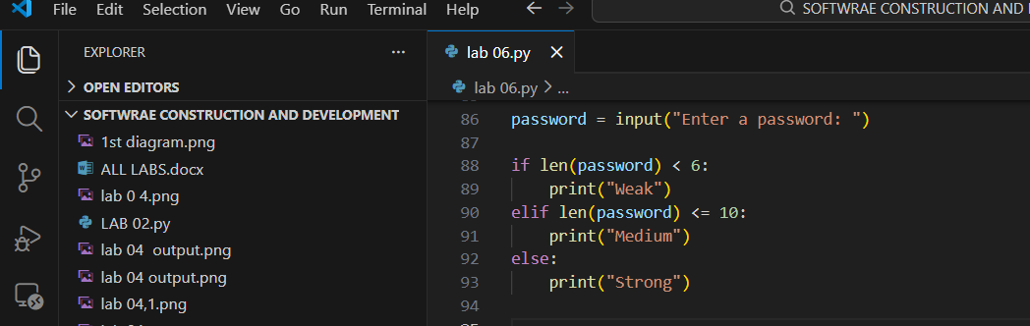

Output:
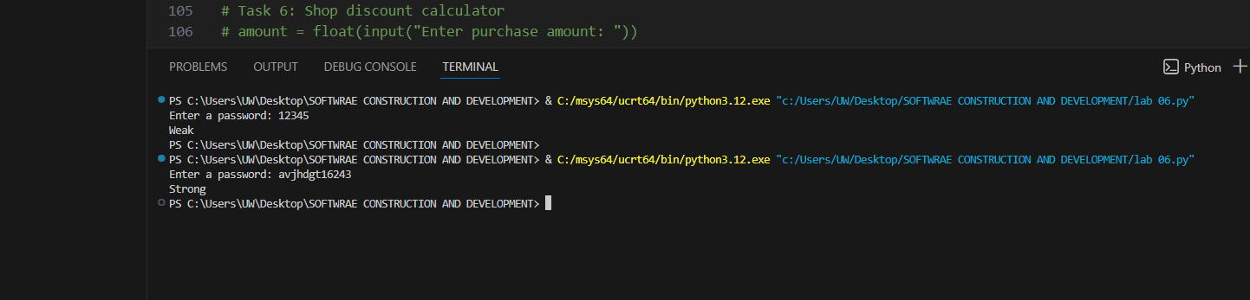

Task 5:

Speed classification
speed = float(input("Enter speed: "))

if speed == 0:
print("No fine")
elif speed <= 60:
print("Small fine")
else:
print("Heavy fine")
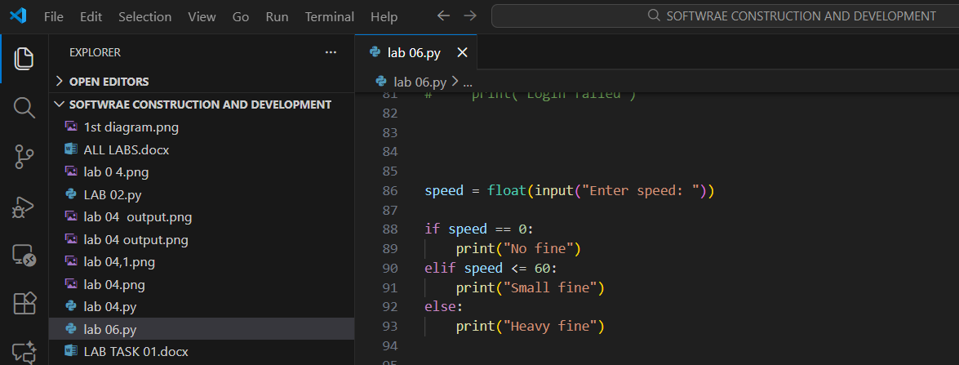

Output:
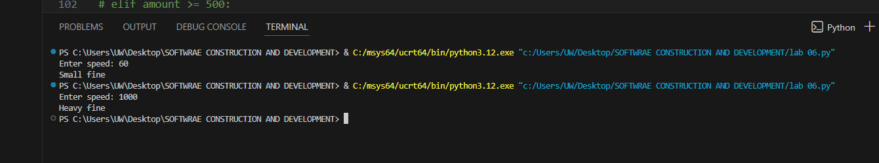

Task 6:

Shop discount calculator
amount = float(input("Enter purchase amount: "))

if amount >= 1000:
discount = amount * 0.20
elif amount >= 500:
discount = amount * 0.10
else:
discount = 0

final_price = amount - discount
print("Final price:", final_price)
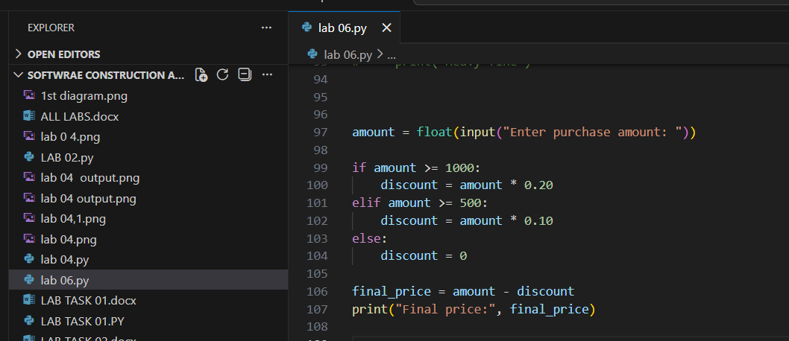

Output:
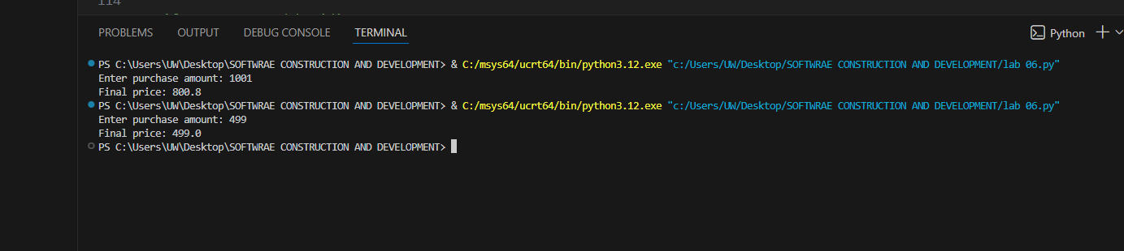

Task 7:

Weather classifier
temp = float(input("Enter temperature: "))
humidity = float(input("Enter humidity: "))
wind_speed = float(input("Enter wind speed: "))

if temp > 30 and humidity > 70:
print("Pleasant")
elif temp < 10 or wind_speed > 50:
print("Harsh")
else:
print("Normal")
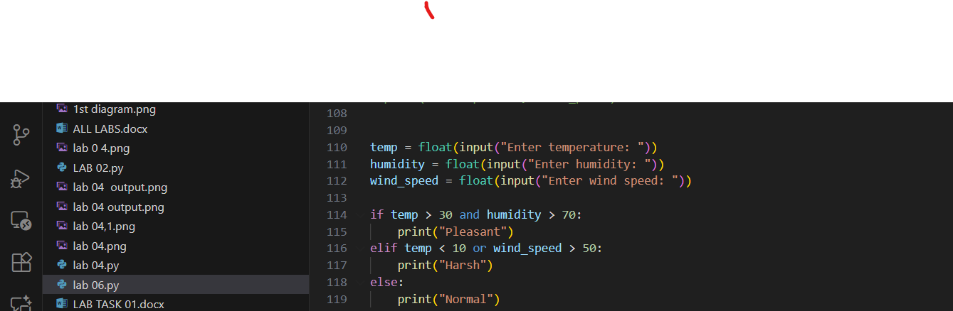

Output:
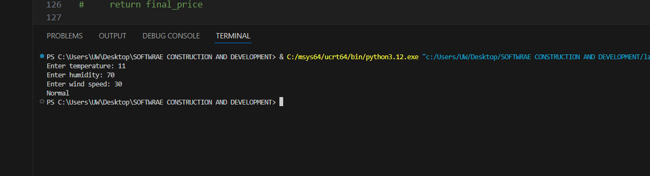

Task 8:

Function for final price with tax
def calculate_final_price(price, tax_percentage):
tax = price * (tax_percentage / 100)
final_price = price + tax
return final_price
price = float(input("Enter price: "))
tax = float(input("Enter tax percentage: "))
result = calculate_final_price(price, tax)
print("Final price after tax:", result)
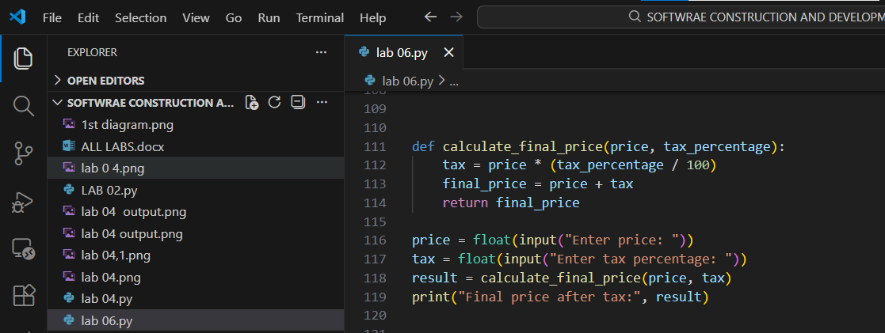

Output:
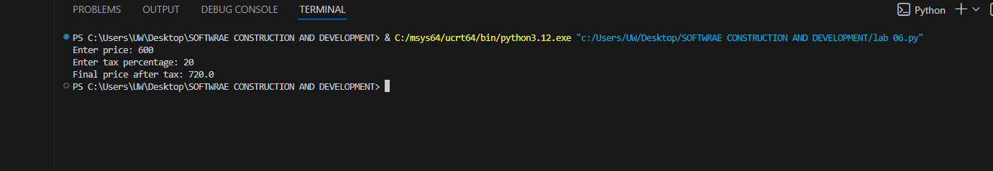

Task 9:

Function to calculate factorial
def factorial(n):
if n == 0 or n == 1:
return 1
result = 1
for i in range(2, n + 1):
result *= i
return result
num = int(input("Enter a number: "))
print("Factorial:", factorial(num))
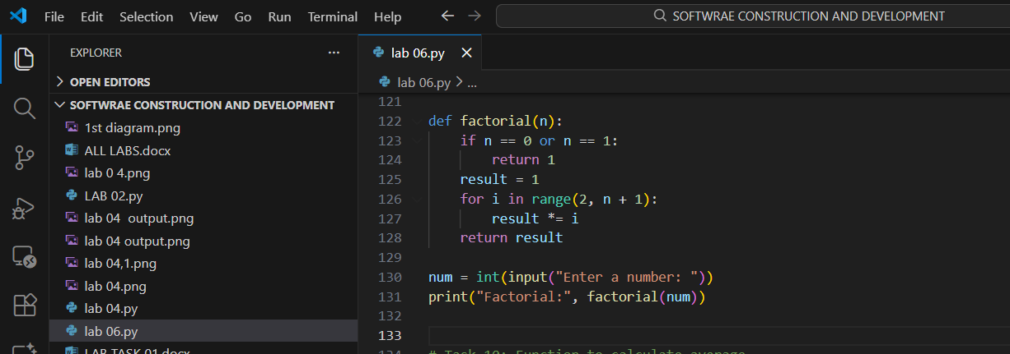

Outpu:
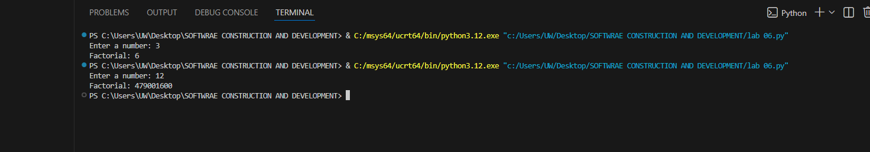

Task 10:

Function to calculate average
def calculate_average(numbers):
if len(numbers) == 0:
return 0
return sum(numbers) / len(numbers)
numbers = [10, 20, 30, 40, 50]
print("Average:", calculate_average(numbers))
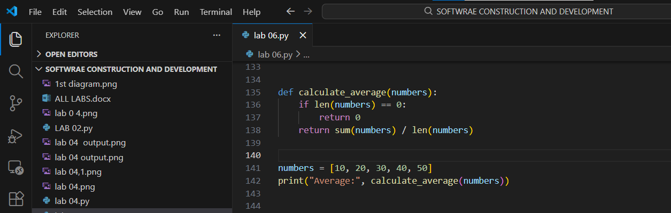

Output:
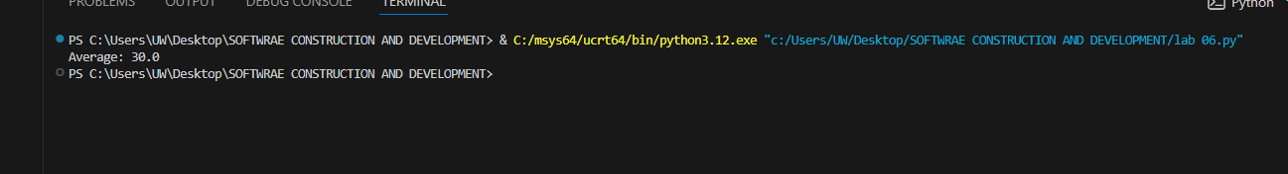

Task 11:

Temperature classification function
def classify_temperature(celsius):
if celsius < 10:
return "Cold"
elif 10 <= celsius <= 25:
return "Warm"
else:
return "Hot"
temp = float(input("Enter temperature in Celsius: "))
print(classify_temperature(temp))
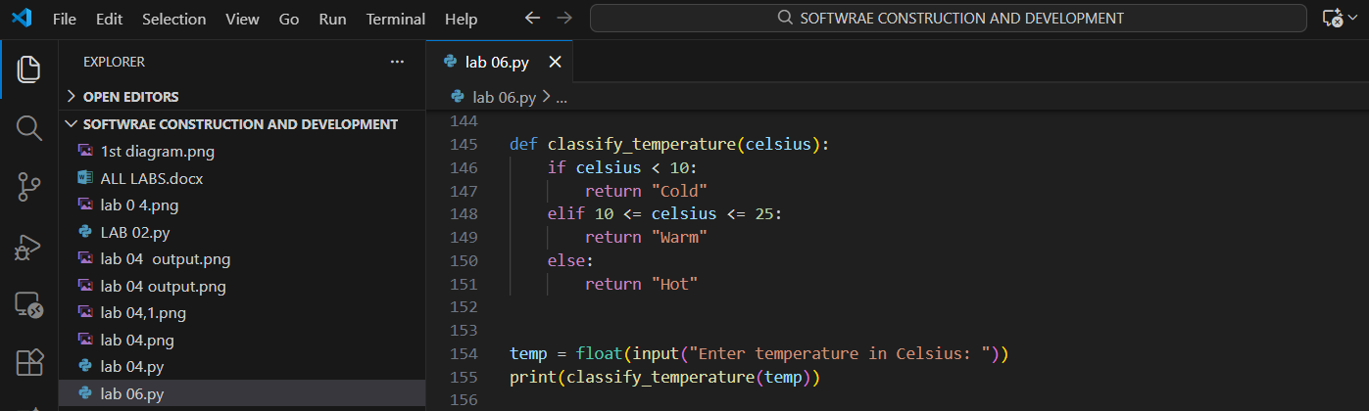

Output:
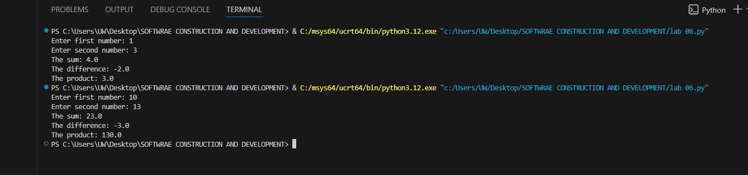

Task 12:

Function for sum, difference, and product
def calculate(num1, num2):
sum_result = num1 + num2
difference = num1 - num2
product = num1 * num2
return sum_result, difference, product
a = float(input("Enter first number: "))
b = float(input("Enter second number: "))
sum_val, diff_val, prod_val = calculate(a, b)
print("The sum:", sum_val)
print("The difference:", diff_val)
print("The product:", prod_val)
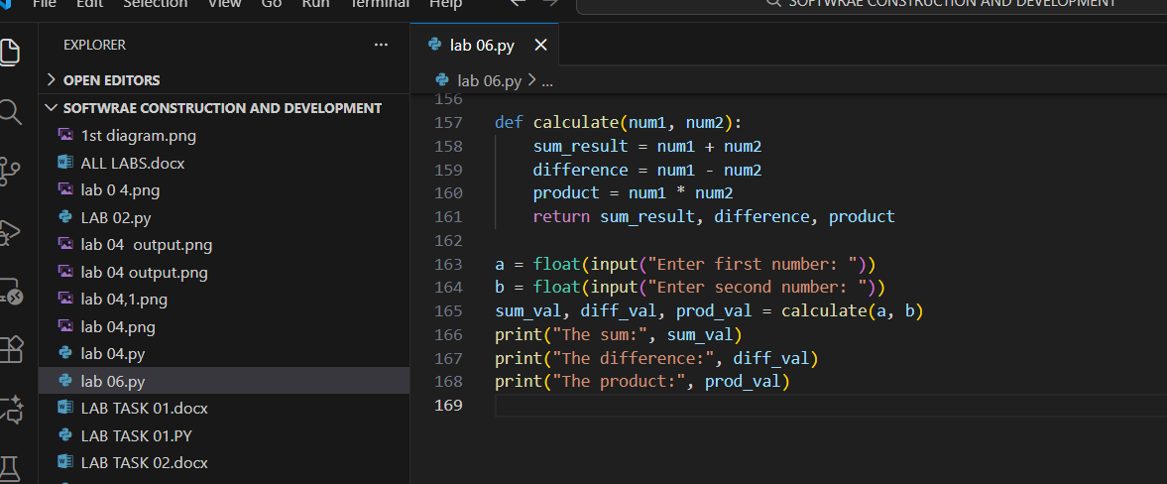
Output:

End:

